Project Design Phase-**|**

**Solution Architecture**

**--------------------------------------------------------------------------------------------**

|  |  |
| --- | --- |
| NAME | T.SURESH KUMAR |
| NM ID | EA32343CFBC1AD09D4E465F983490A2F |
| PROJECT | HOW TO CREATE A GOOGLE ADS COMPAIGN FOR YOUR BRAND |

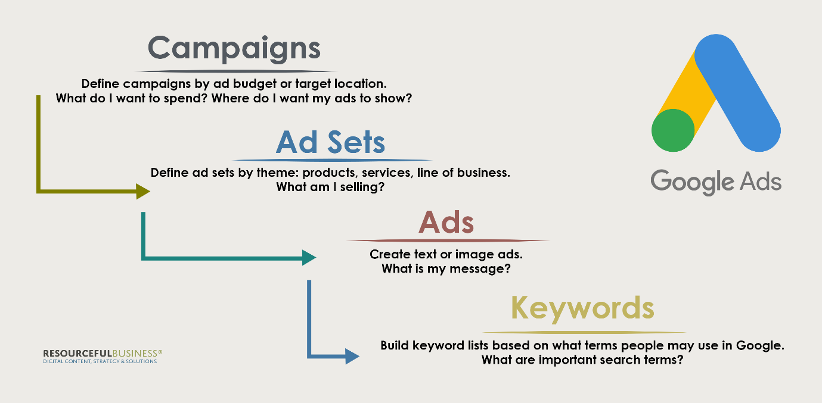

**1. User Interface:**

**- The solution should have a user interface that allows marketers and advertisers to input campaign details, including ad copy, targeting options, and budget settings. This interface can be a web application or a standalone software.**

**2. Authentication and Authorization:**

**- Users should be authenticated to access the system. OAuth or other authentication mechanisms can be used for secure access.**

**3. Frontend Application:**

**- This component handles user interactions and communicates with the backend services. It should provide a user-friendly interface for campaign management.**

**4. Backend Services:**

**- The backend consists of several services that handle different aspects of campaign creation and management:**

**- User Management Service: Manages user accounts, permissions, and access control.**

**- Campaign Configuration Service: Allows users to define campaign settings, such as budget, targeting, and ad creative.**

**- Google Ads API Integration: This service interacts with the Google Ads API to create, manage, and optimize campaigns.**

**- Data Storage: Stores campaign data, user profiles, and historical performance data.**

**- **Notification Service: Sends alerts and notifications to users about campaign updates or issues.**

**- **Reporting Service: Gathers and processes campaign performance data for reporting and analytics.**

**5. Google Ads API Integration:**

**- This component communicates with the Google Ads API to create and manage campaigns, ad groups, ads, and keywords. It should handle authentication, making API requests, and receiving responses.**

**6. Data Storage:**

**- Campaign data, user profiles, and historical performance data should be stored securely. You can use databases (e.g., SQL or NoSQL databases) for this purpose.**

**7. Reporting and Analytics:**

**- Collects campaign performance data and generates reports. Data visualization tools or dashboards can be used to present insights to users.**

**8. Notifications:**

**- The notification service sends alerts to users for various events, such as campaign approvals, policy violations, or budget overspending.**

**9. Monitoring and Logging:**

**- Implement monitoring and logging to track system health, performance, and errors. Tools like Prometheus and Grafana can be used for monitoring.**

**10. Security Measures:**

**- Implement security measures at every layer, including encryption of sensitive data, API authentication, and access control to prevent unauthorized access.**

**11. Compliance:**

**- Ensure compliance with Google Ads policies and regulations to avoid any policy violations during campaign creation and management.**

**12. Testing and Quality Assurance:**

**- Develop a testing strategy to ensure that the system works as expected and does not have any critical issues. Automated testing can help in this regard.**

**13. Deployment and Scalability:**

**- Deploy the solution in a scalable and reliable environment. Use containerization (e.g., Docker) and orchestration (e.g., Kubernetes) for managing services.**

**14. Disaster Recovery and Backup:**

**- Implement a disaster recovery plan to ensure data integrity and availability in case of system failures.**

**15. Documentation:**

**- Document the solution architecture, APIs, and user guides for the marketing team and developers.**

**16. Continuous Optimization:**

**- Continuously monitor campaign performance and optimize based on data insights. This may involve adjusting bidding strategies, ad creatives, and targeting options.**